CHM 101A CA ASSIGMENT I

SOLUTION

MR. ABDULLAHI D. K.
QUESTION

NOTE: Some of the values given in yellow where not correct os here is the correct value in yellow.
So what do we do with the ASSIGNMENT? COMMENT ……….
The rate of the following reaction in aqueous solution is monitored by measuring the number of moles of Hg₂Cl₂ that precipitate per liter per minute. The data obtained are listed in the table.
2 HgCl₂(aq) + C₂O₄^{2–}(aq) → 2 Cl–(aq) + 2 CO₂(g) + Hg₂Cl₂(s)
Experiment [HgCl₂] (M) [C₂O₄^{2–}] (M) Initial rate (mol L^{–1} min^{–1})
1 0.105 0.15 1.8×10^{–5}
2 0.105 0.30 1.8×10^{–5}
3 0.052 0.30 3.5×10^{–5}
4 0.052 0.15 8.9×10^{–6}
(a) Determine the order of reaction with respect to HgCl₂, with respect to C₂O₄^{2–} and overall.
(b) What is the value of the rate constant k?
(c) What would be the initial rate of reaction if [HgCl₂] = 0.094 M and [C₂O₄^{2–}] = 0.19 M?
(d) Are all four experiments necessary to answer parts (a) - (c)? Explain.

Answer
Use the method of initial rates to find the orders of reaction in each component. This will allow evaluation of the rate constant and the initial rate of reaction at any other condition.
(a) Rate = k[HgCl₂]^{m}[C₂O₄^{2–}]^{n}
Compare the rates in experiments 1 and 2 (or 3 and 4) to find the order in oxalate ion:
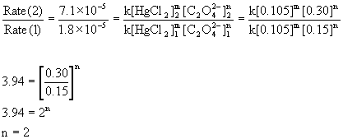
Compare the rates in experiments 2 and 3 (or 1 and 4) to find the order in mercury(II) chloride:

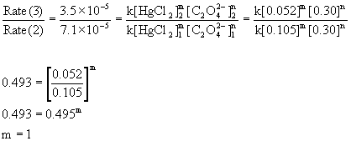
Therefore, the reaction is first order with respect to mercury(II) chloride and second order with respect to oxalate. The overall order is the sum of these, 2 + 1 = 3, third order.
(b) To find the rate constant, use the rate equation and solve for k:
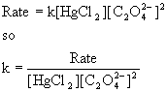
Experiment [HgCl₂] (M) [C₂O₄^{2–}] (M) Initial rate (mol L^{–1} min^{–1})k
1 0.105 0.15 1.8×10^{–5}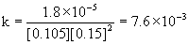
2 0.105 0.30 1.8×10^{–5}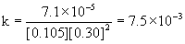
3 0.052 0.30 3.5×10^{–5}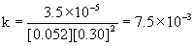
40.0520.158.9×10^{–6}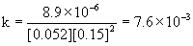
The average k = 7.6×10^{–3} M^{–2}min^{–1}
(c) Rate = k[HgCl₂][C₂O₄^{2–}]²
Rate = (7.6×10^{–3} M^{–2}min^{–1}) [0.094 M] [0.19 M]² = 2.6×10^{–5} M min^{–1}
(d) Since there are only two reactants, three experiments are the minimum required to find the rate equation and rate constant. Experiments 1 - 3 would have sufficed to answer the questions posed.

